SIMATS ENGINEERING
ASSESSMENT TOOL 2
COURSE NAME: Artificial Intelligence COURSE CODE: CSA17

COURSE OUTCOME COVERED
CO1: Apply AI basics such as intelligent agents and uninformed search methods to solve problems effectively.( BL3)
Assessment Tool Weightage: 35%

QUESTIONS: 3 Duration : 1 Hour
Total Marks:30
Annexure A
Constraint-Based Problem Solving

Code of Conduct:
I P.Revanthsai / 192525451 (Name / Reg No) certify that this submission is my original work and that I have adhered to the guidelines specified for this assessment.
I understand that any violation of academic integrity rules will result in disciplinary action.
Signature of the student:

Annexure A
Constraint-Based Problem Solving
Question 1
1. A hospital needs to assign 3 doctors (D1, D2, D3) to 3 shifts (Morning, Afternoon, Night) such that: Constraints: i. D1 cannot work Night shift. ii. D2 must work before D3 (Morning < Afternoon < Night). iii. Only one doctor per shift. iv. D3 cannot work Morning. v. All doctors must be assigned exactly one shift. Apply Backtracking Search to find a valid assignment with all intermediate steps and constraint checks. State the final valid schedule.
Answer:
1.1 Problem Understanding
This is a Constraint Satisfaction Problem (CSP). Each doctor must be given exactly one of three shifts so that every constraint holds at the same time. A CSP is described by variables, domains and constraints, and it is solved by assigning values one variable at a time while checking constraints (backtracking search).
1.2 CSP Formulation
- Variables: D1, D2, D3 (the doctors).
- Domain of each variable: {Morning (M), Afternoon (A), Night (N)}, ordered M < A < N.
- Constraints:
No. | Constraint | Type | Formal form
i | D1 cannot work Night | Unary | D1 ≠ N
ii | D2 works before D3 | Binary | D2 < D3 (in the order M < A < N)
iii | Only one doctor per shift | Binary (all-different) | D1 ≠ D2, D1 ≠ D3, D2 ≠ D3
iv | D3 cannot work Morning | Unary | D3 ≠ M
v | Every doctor gets exactly one shift | Implicit | Each variable receives exactly one value

Node consistency (unary constraints applied first): constraint (i) removes N from the domain of D1 and constraint (iv) removes M from the domain of D3, so the reduced domains are:
Variable | Original domain | Domain after unary constraints
D1 | {M, A, N} | {M, A}
D2 | {M, A, N} | {M, A, N}
D3 | {M, A, N} | {A, N}

Constraint graph: D1, D2 and D3 are all linked by the “different shift” constraint, and D2 and D3 have the extra ordering link D2 < D3. Without any search, a plain generate-and-test would try all 3³ = 27 assignments (or 3! = 6 if shifts are not repeated). Backtracking prunes the search by rejecting a partial assignment as soon as it breaks a constraint.
1.3 Backtracking Search Procedure
Variables are assigned in the order D1, D2, D3, and values are tried in the order Morning, Afternoon, Night. After every assignment, all constraints whose variables are already assigned are checked. If a check fails, the algorithm backtracks to the most recent choice and tries the next value.
Pseudocode
function BACKTRACKING-SEARCH(csp) returns a solution or failure
return BACKTRACK({ }, csp)

function BACKTRACK(assignment, csp) returns a solution or failure
if assignment is complete then return assignment
var ← SELECT-UNASSIGNED-VARIABLE(csp) // D1, then D2, then D3
for each value in ORDER-DOMAIN-VALUES(var, csp) do
if value is consistent with assignment then // check constraints i-v
add {var = value} to assignment
result ← BACKTRACK(assignment, csp)
if result ≠ failure then return result
remove {var = value} from assignment // backtrack
return failure
1.4 Step-by-Step Execution with Constraint Checks
Step | Assignment tried | Constraint checks | Result
1 | D1 = Morning | (i) D1 ≠ N: satisfied. No other variable assigned yet. | ✓ Consistent, continue
2 | D1 = M, D2 = Morning | (iii) D2 = M clashes with D1 = M (one doctor per shift) | ✗ Violated, try next value
3 | D1 = M, D2 = Afternoon | (iii) M ≠ A satisfied; (ii) cannot be tested until D3 is assigned | ✓ Consistent, continue
4 | D1 = M, D2 = A, D3 = Morning | (iv) D3 ≠ M violated; also (iii) clashes with D1 | ✗ Violated, try next value
5 | D1 = M, D2 = A, D3 = Afternoon | (iii) D3 = A clashes with D2 = A; also (ii) A < A is false | ✗ Violated, try next value
6 | D1 = M, D2 = A, D3 = Night | (i) satisfied; (ii) A < N true; (iii) M, A, N are all different; (iv) D3 ≠ M true; (v) all three assigned | ✓ All constraints satisfied. Solution found

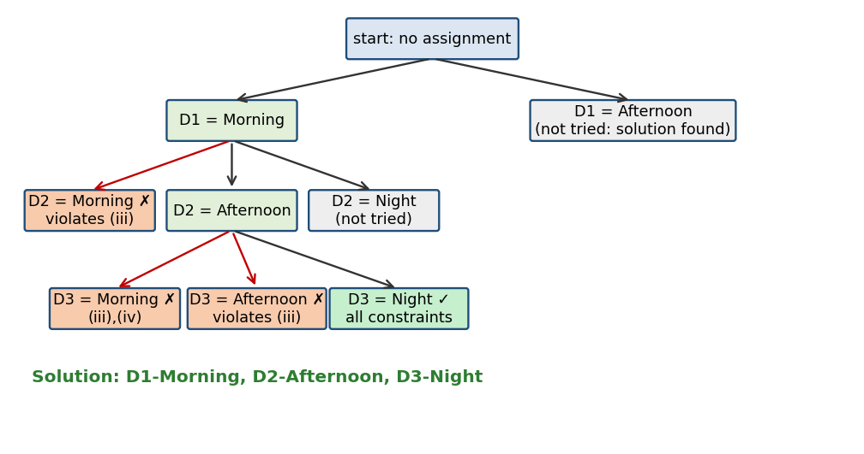
Figure 1: Backtracking search tree (✗ = constraint violated, ✓ = solution)
Backtracking happened twice (at steps 2, 4 and 5 the algorithm had to reject a value and try the next one). The branch D1 = Afternoon was never explored because a solution was found first. Domain value Night for D1 had already been removed by constraint (i).
1.5 Verification and Final Schedule
Constraint | Check on final schedule | Status
i. D1 not on Night | D1 works Morning | Satisfied
ii. D2 before D3 | D2 = Afternoon, D3 = Night, and Afternoon < Night | Satisfied
iii. One doctor per shift | Morning, Afternoon and Night each have exactly one doctor | Satisfied
iv. D3 not on Morning | D3 works Night | Satisfied
v. Each doctor exactly one shift | D1, D2, D3 each have one shift | Satisfied

Shift | Doctor
Morning | D1
Afternoon | D2
Night | D3

Note: the problem has a second valid schedule, D1 = Afternoon, D2 = Morning, D3 = Night, which backtracking would find if the first were rejected. Using heuristics such as Minimum Remaining Values (assign D3 first, since only A or N remain) or forward checking would reach the answer with fewer failed attempts.
Final valid schedule: D1 → Morning, D2 → Afternoon, D3 → Night.

Question 2
2. A robot operates in a grid environment (5×5). It must move from Start (S) to Goal (G). Obstacles block certain paths. Constraints: i. Movement allowed: Up, Down, Left, Right. ii. Cost of each move = 1. iii. Cannot pass through obstacles. iv. Use Manhattan Distance heuristic. Using above constraints and BFS Search Algorithm show step-by-step node expansion and priority queue updates and determine the optimal path and cost.
Answer:
2.1 Problem Understanding and Grid Used
The robot moves on a 5 × 5 grid, one cell at a time (Up, Down, Left, Right), every move costs 1, and obstacle cells cannot be entered. Cells are written as (row, column) with (0,0) at the top left. The grid considered for the demonstration is shown in Figure 2: S = (0,0), G = (4,4) and obstacles at (1,1), (1,3), (2,1) and (3,3). The same method applies to any other placement of S, G and obstacles.
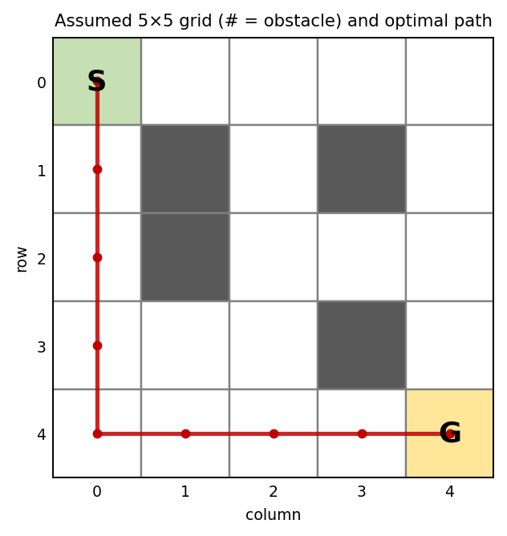
Figure 2: The 5×5 grid and the optimal path found (red)
2.2 Problem Formulation
- State: the robot’s cell (r, c), not an obstacle.
- Initial state: S = (0, 0). Goal test: state = G = (4, 4).
- Actions: Up, Down, Left, Right (when the target cell is inside the grid and not an obstacle). Neighbours are generated in the order Up, Down, Left, Right.
- Step cost: 1 for every move. Heuristic: Manhattan distance h(r, c) = |r − 4| + |c − 4|, e.g. h(S) = 8.
The Manhattan heuristic is admissible (it never overestimates, because every move changes the distance by at most 1) and consistent, so A* with it is optimal.
2.3 Method Selection
The question asks for BFS but also mentions a priority queue and the Manhattan heuristic. Plain BFS uses a FIFO queue and ignores the heuristic; because every move costs 1, BFS returns the shortest (minimum-cost) path. A priority queue ordered by f(n) = g(n) + h(n) is what A\* search uses. Both are therefore shown: Part A gives BFS with its queue, and Part B shows the priority-queue (A*) version with the Manhattan heuristic, for comparison.
2.4 Part A: BFS Node Expansion (FIFO queue)
g(n) is the number of moves from S. The goal test is applied when a node is generated. The queue column shows the contents after each expansion (front on the left).
Step | Node expanded | Nodes added to queue | Queue after step
1 | (0,0) g=0 | (1,0), (0,1) | (1,0) (0,1)
2 | (1,0) g=1 | (2,0) | (0,1) (2,0)
3 | (0,1) g=1 | (0,2) | (2,0) (0,2)
4 | (2,0) g=2 | (3,0) | (0,2) (3,0)
5 | (0,2) g=2 | (1,2), (0,3) | (3,0) (1,2) (0,3)
6 | (3,0) g=3 | (4,0), (3,1) | (1,2) (0,3) (4,0) (3,1)
7 | (1,2) g=3 | (2,2) | (0,3) (4,0) (3,1) (2,2)
8 | (0,3) g=3 | (0,4) | (4,0) (3,1) (2,2) (0,4)
9 | (4,0) g=4 | (4,1) | (3,1) (2,2) (0,4) (4,1)
10 | (3,1) g=4 | (3,2) | (2,2) (0,4) (4,1) (3,2)
11 | (2,2) g=4 | (2,3) | (0,4) (4,1) (3,2) (2,3)
12 | (0,4) g=4 | (1,4) | (4,1) (3,2) (2,3) (1,4)
13 | (4,1) g=5 | (4,2) | (3,2) (2,3) (1,4) (4,2)
14 | (3,2) g=5 | — | (2,3) (1,4) (4,2)
15 | (2,3) g=5 | (2,4) | (1,4) (4,2) (2,4)
16 | (1,4) g=5 | — | (4,2) (2,4)
17 | (4,2) g=6 | (4,3) | (2,4) (4,3)
18 | (2,4) g=6 | (3,4) | (4,3) (3,4)
19 | (4,3) g=7 | (4,4) | (3,4) (4,4)

BFS expanded 19 nodes and generated G at step 19. Tracing the parent pointers back from G gives the path below.
2.5 Part B: A* with Manhattan Heuristic (priority queue)
The priority queue is ordered by f = g + h; ties are broken by smaller h and then by first-in order. In the queue column, “(r,c):f” shows each waiting node with its f value.
Step | Node expanded | Nodes added / updated | Priority queue after step
1 | (0,0) g=0 h=8 f=8 | (1,0) f=8, (0,1) f=8 | (1,0):8 (0,1):8
2 | (1,0) g=1 h=7 f=8 | (2,0) f=8 | (2,0):8 (0,1):8
3 | (2,0) g=2 h=6 f=8 | (3,0) f=8 | (3,0):8 (0,1):8
4 | (3,0) g=3 h=5 f=8 | (4,0) f=8, (3,1) f=8 | (4,0):8 (3,1):8 (0,1):8
5 | (4,0) g=4 h=4 f=8 | (4,1) f=8 | (4,1):8 (3,1):8 (0,1):8
6 | (4,1) g=5 h=3 f=8 | (4,2) f=8 | (4,2):8 (3,1):8 (0,1):8
7 | (4,2) g=6 h=2 f=8 | (3,2) f=10, (4,3) f=8 | (4,3):8 (3,1):8 (0,1):8 (3,2):10
8 | (4,3) g=7 h=1 f=8 | (4,4) f=8 | (4,4):8 (3,1):8 (0,1):8 (3,2):10
9 | (4,4) g=8 h=0 f=8 | Goal test succeeds | —

A* expands only 9 nodes compared with BFS’s 19, because the heuristic guides the search toward G, but both give the same optimal cost.
2.6 Optimal Path and Cost
Item | Result
Optimal path | (0,0) → (1,0) → (2,0) → (3,0) → (4,0) → (4,1) → (4,2) → (4,3) → (4,4)
Moves | Down, Down, Down, Down, Right, Right, Right, Right
Path cost | 8 moves × 1 = 8
Nodes expanded | BFS: 19 | A*: 9

Interpretation: the cost 8 equals the Manhattan distance from S to G, so no path can be shorter; the obstacles did not lengthen the route. Other optimal paths of cost 8 also exist, for example through (0,1), (0,2), (1,2), (2,2), (2,3), (2,4), (3,4), and BFS returns the first one found because of the neighbour order. Optimality is guaranteed for BFS (equal step costs) and for A* (admissible heuristic).
Conclusion: the robot reaches G from S with an optimal cost of 8.

Question 3
3. An autonomous rescue robot is deployed in a disaster-affected building to locate and rescue survivors. The robot operates in a partially observable environment where some paths are blocked, and it must make decisions with limited information. The building is represented as a grid of rooms. The robot starts at position S and must reach a survivor located at G. Constraints: the robot can move up, down, left, right; some cells are blocked; limited sensing (adjacent cells only); each movement costs 1, entering risky zones adds 2; minimise total cost while ensuring safe navigation; update knowledge dynamically (online search). Tasks: a) Analyse the constraints and explain their effect on decision-making. b) Develop a solution approach using an appropriate search strategy and explain the steps. c) Demonstrate how the robot applies intelligent agents, rationality and environment type. d) Justify why the chosen approach is most suitable.
Answer:
3a) Analysis of the Constraints
Constraint | Effect on the robot’s decision making
Moves: up, down, left, right | Gives at most 4 actions per cell on a 4-connected grid; no diagonal shortcuts, so Manhattan distance is a lower bound on cost
Blocked cells | Some actions are illegal. The robot never plans through a known obstacle, and a newly found obstacle can invalidate the current plan, forcing re-planning or backtracking
Limited sensing (adjacent cells only) | The environment is partially observable. The global optimum cannot be computed in advance, so the robot plans with what it knows and improves its map as it moves
Cost 1 per move, +2 for risky cells | A risky cell costs 3 instead of 1, so the fewest-step path is not always the cheapest; a detour of up to 2 extra steps beats crossing one risky cell
Minimise cost with safe navigation | Safety and cost are balanced: risky cells are used only if the detour costs more than the penalty or no safe route exists
Online knowledge update | Planning and acting are interleaved (act, sense, update, re-plan). Moves are real and may be irreversible, so exploration itself has a cost

Priority of constraints: (1) hard constraints first: legal moves, blocked cells and reaching G (feasibility and safety); (2) cost minimisation (move cost plus risk penalty) among the feasible plans; (3) sensing limits and online updating decide what the planner knows at each moment.
3b) Solution Approach: Online Uniform Cost Search with Re-planning
The approach is an online search agent that runs Uniform Cost Search (UCS) on its current map and re-plans after every observation. UCS is chosen because step costs are unequal (1 for a normal cell, 3 for a risky cell), so BFS would not be cost-optimal; A* with Manhattan distance (admissible, since the minimum step cost is 1) can replace UCS to expand fewer nodes. Unknown cells are assumed free and safe (the optimistic “free-space” assumption).
- Initialise: position = S; known map empty except S; goal = G.
- Sense: observe the four adjacent cells and record each as free, blocked or risky.
- Update the known map; unknown cells stay “assumed free”.
- Plan: run UCS from the current cell to G on the known map (cost 1 normal, 3 risky, blocked excluded).
- Act: execute only the first move of the plan and add its cost to the total.
- Repeat steps 2–5 until G is reached. If no path exists on the known map, explore the nearest unknown cell; if none remain, report G unreachable.
function ONLINE-RESCUE-AGENT(S, G)
pos ← S; known ← empty map; total ← 0
while pos ≠ G do
SENSE(pos): record adjacent cells as free / blocked / risky in known
plan ← UCS(known, pos, G) // unknown = free (1), risky = 3
if plan = failure then explore nearest unknown cell / report fail
next ← FIRST-STEP(plan); total ← total + STEP-COST(next)
pos ← next // physically move
return total
Demonstration on an Example Building
In the 5 × 5 building of Figure 2 (dark = blocked, orange = risky) the robot does not know the map in advance. It starts at S = (0,0) and must reach G = (4,4).
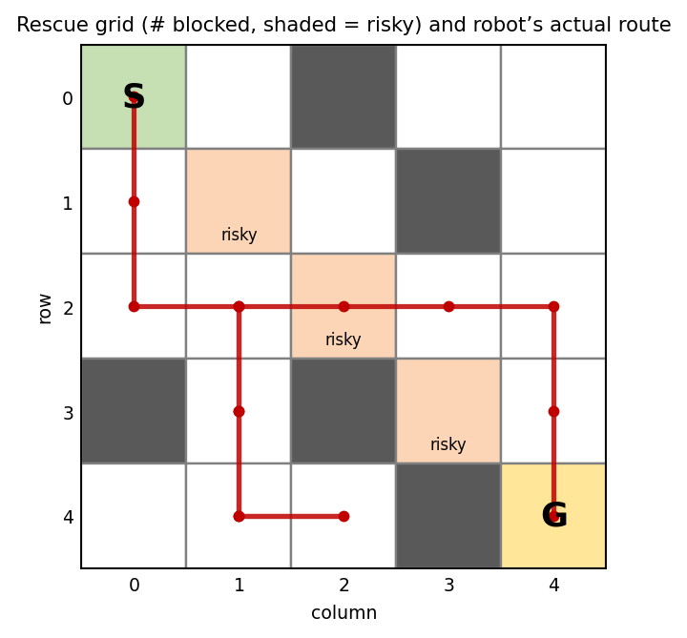
Figure 2: Rescue grid and the robot’s actual route (red)
Move | Position | Newly sensed | Plan from here (est. cost) | Action | Cost
0 | (0,0) | none | same route, est. 8 | — | 0
1 | (1,0) | (1,1) risky | same route, est. 7 | plan kept | 1
2 | (2,0) | (3,0) blocked | (2,0)→(2,1)→(3,1)→(4,1)→(4,2)→(4,3)→(4,4) (est. 6) | re-planned | 2
3 | (2,1) | (2,2) risky | same route, est. 5 | plan kept | 3
4 | (3,1) | (3,2) blocked | same route, est. 4 | plan kept | 4
6 | (4,2) | (4,3) blocked | (4,2)→(4,1)→(3,1)→(2,1)→(2,2)→(2,3)→(3,3)→(3,4)→(4,4) (est. 10) | re-planned | 6
11 | (2,3) | (1,3) blocked; (3,3) risky | (2,3)→(2,4)→(3,4)→(4,4) (est. 3) | re-planned | 13
14 | (4,4) | none | — | goal reached | 16

- At the start every unknown cell is assumed free, so the robot plans straight down the left column (est. 8). At (2,0) it senses (3,0) blocked and re-plans through (2,1) and (3,1).
- At (4,2) it senses (4,3) blocked, so the plan is invalid; the robot backtracks over known cells and takes a middle route. At (2,2) the only way forward is a risky cell (the other route via (1,1) is also risky), so it pays the penalty once (1 + 2 = 3).
- At (2,3) it senses (3,3) risky and (1,3) blocked, and re-plans via (2,4) and (3,4) to reach G.
Total cost = 16 (14 moves + 2 risk penalty). With the whole map known in advance the optimum would be 10, so the extra 6 is the price of exploring with limited information.
3c) Application of AI Concepts
Intelligent agent (PEAS). Performance: reach the survivor at minimum total cost (moves + risk penalties) without entering blocked cells. Environment: a disaster-hit building modelled as a grid with blocked and risky cells. Actuators: wheels/tracks for Up, Down, Left, Right and stop. Sensors: adjacent-cell obstacle and hazard sensors and a position estimate. The robot is a goal-based, model-based agent with a cost (utility) measure: it keeps an internal map because it cannot see everything, has the goal G, and picks actions by cost.
Rationality. A rational agent picks the action expected to maximise its performance measure given its percepts and knowledge. Here that means taking, at every step, the first move of the least-cost plan on the current knowledge, never entering known blocked cells, using a risky cell only when the alternative costs more, and re-planning when a new percept changes the picture. Rationality is not omniscience: the extra cost of 6 in the example is not irrational, since the blocked cells could not be known beforehand.
Environment property | Type | Reason
Observability | Partially observable | Only adjacent cells are sensed
Agents | Single agent | Only the robot acts; the survivor is passive
Determinism | Deterministic (assumed) | A move succeeds as intended; noise could make it stochastic
Episodic / sequential | Sequential | Each move changes position and all later costs
Static / dynamic | Mostly static | Debris or fire could change it, which the online loop handles
Discrete / continuous | Discrete | Grid cells and four actions
Known / unknown | Unknown | The map must be learned by exploration
3d) Justification of the Chosen Approach
- Unequal costs: UCS (or A*) minimises total cost including the +2 risk penalty; BFS and DFS ignore costs.
- Partial observability: an offline planner needs the full map; the online loop plans with current knowledge and corrects itself after each observation.
- Safety: blocked cells are never planned through and risky cells are priced so they are used only if worthwhile.
- Completeness and optimality: with positive step costs UCS is complete and returns the cheapest path on the known map; as the map is learned the route approaches the true optimum, and in a finite, safely explorable grid the agent reaches G whenever a path exists.
- Compared with alternatives: a reactive agent gets stuck in dead ends, greedy best-first ignores risk cost, and offline A* is impossible without the map. For large maps D* Lite or LRTA* can reuse earlier work.
Conclusion: an online agent that senses, updates its map and re-plans with Uniform Cost Search (or A*) is the most suitable rational approach, since it respects the safety and cost constraints while coping with limited information.

